Research Paper Assignment
  - Decentralized Docker IDEs for Computer Science Education
UNLV · CS 135 (C++) and CS 218 (x86-64 assembly) course environments · August 2026

1. Assignment status and scope
The literature listed below is a strong and sufficient base for beginning this research paper. It establishes the history of standardized course environments, compares institutional servers, cloud systems, virtual machines, Docker containers, desktop and browser IDEs, and includes empirical work on setup friction, student anxiety, instructor support, and assembly-language virtualization.
The software repository is complete, but the educational study is not, because the images have not yet been deployed in courses. The paper is therefore written in two stages:
1. Before course deployment: write the introduction, related work, course context, requirements, system design, reproducibility information, technical evaluation, limitations, and planned educational evaluation.
2. After course deployment: add student and instructor data, analyze the research questions involving usability and learning, and revise the discussion and conclusion.
Until course data exist, describe the work as a system paper, design report, or technical experience report with a study protocol. Do not claim that the system improves learning, reduces anxiety, or reduces support work until those outcomes have been measured.

2. Suggested paper titles
Choose or adapt one of the following:
1. From Cloud Containers to Local Course Appliances: Decentralized Browser-Based IDEs for C++ and x86-64 Assembly Education
2. A Decentralized, Browser-Based Docker IDE for Resource-Constrained Computer Science Courses
3. Standardizing C++ and x86-64 Assembly Environments with Local Browser-Based Docker IDEs
4. Local Containers, Browser IDEs, and Host-Owned Files: A Course Environment for Introductory Systems Programming

3. Central argument
Do not frame the contribution as the first use of Docker in computer science education — the literature clearly establishes earlier containerized course environments. Instead, develop and test the following argument:
Cloud programming environments make standardized browser-based development accessible, but they introduce service, network, account, cost, and institutional-infrastructure dependencies. Local development containers remove many of those dependencies but often require a separately installed desktop editor and may leave persistence and lifecycle behavior implicit. This project combines a locally executed Docker container, a browser-based VS Code interface, explicit host bind mounts, instructor-controlled toolchains, offline operation after the initial pull, and course-specific architecture handling to provide a decentralized course appliance for C++ and x86-64 assembly education.
This argument identifies the project as a particular point in the design space rather than claiming that every local container is superior to every cloud environment.

4. Design contributions to investigate
Present the following as design contributions. Their educational effects remain research questions until evaluated.
1. Decentralized execution: one container runs on each student's machine; no university server or course-operated cluster is required.
2. Browser-based professional interface: students use code-server, which provides a VS Code-style editor, file explorer, terminal, extensions, and run commands through localhost.
3. Instructor-controlled environments: compiler, assembler, debugger, editor, extensions, settings, and versions are defined in the image.
4. Host-owned student work: bind mounts place coursework in an ordinary host folder rather than in a container layer or hidden Docker volume.
5. Safe replacement and updating: images and containers can be replaced without replacing the bind-mounted workspace.
6. Offline-capable operation: after the image has been pulled, compilation and editing occur locally without a course server.
7. Resource-conscious lifecycle: containers start only when requested; no restart policy is used; students are given stop procedures and optional CPU and memory caps.
8. Two architecture strategies: the C++ image is native on amd64 and arm64, while the x86-64 assembly image remains amd64-only so that the course's actual instruction set and Linux ABI are preserved.
9. Documented emulation boundary: assembly, linking, and execution work under Docker Desktop emulation on ARM hosts, while gdb/ptrace assignments require native amd64 hardware.
10. AI-free instructional surface: editor AI, chat, agents, Copilot-style features, and inline suggestions are disabled to preserve the courses' instructional policy. Treat this as a design requirement, not as evidence that learning improved.

5. Research objectives

5.1 Technical objectives
- Define a reproducible C++ environment for CS 135 and an x86-64 Linux assembly environment for CS 218.
- Make both environments accessible through a consistent browser interface.
- Verify documented student workflows against the published images.
- Evaluate portability across operating systems and processor architectures.
- Measure startup time, image size, idle resource use, compilation performance, and emulation overhead.
- Demonstrate that replacing a container or image does not remove bind-mounted student files.
- Document the limits of architecture emulation, especially debugger behavior.

5.2 Educational objectives
- Reduce the time between receiving setup instructions and successfully running the first course program.
- Reduce operating-system-specific setup problems and instructor troubleshooting.
- Allow students to focus on course concepts rather than dependency installation.
- Preserve access to a realistic Linux command line and professional development tools.
- Determine whether students perceive the environment as usable, dependable, and appropriately transparent.
- Determine whether the environment affects setup anxiety, programming self-efficacy, or course participation.
The educational objectives are intended outcomes. They become findings only after a course study supports them.

6. Research questions
Use research questions rather than strong causal hypotheses for the first deployment.

6.1 Answerable before deployment
- RQ1 — Reproducibility: do the published images execute the documented C++ and x86-64 student workflows successfully?
- RQ2 — Portability: which combinations of host operating system and architecture can run each course environment, and what limitations remain?
- RQ3 — Resource cost: what storage, memory, CPU, startup-time, and compilation costs does each environment impose on representative student hardware?
- RQ4 — Persistence: does the documented bind-mount and update process preserve student files across container and image replacement?
- RQ5 — Architecture fidelity: to what extent can an amd64-only assembly environment reproduce the intended course behavior on ARM hosts?

6.2 Requiring course deployment
- RQ6 — Setup success: what percentage of students reaches a working environment without instructor intervention, and how long does setup take?
- RQ7 — Support burden: how many setup incidents and staff minutes are required compared with the prior course setup process?
- RQ8 — Student experience: how do students rate usability, reliability, anxiety, confidence, and their ability to focus on programming?
- RQ9 — Continued use: do students continue using the supplied environment, switch to another environment, or use both, and why?
- RQ10 — Learning: is use of the environment associated with assignment completion or performance after accounting for prior experience and other plausible differences?
RQ10 must be interpreted cautiously. A difference between two semesters, or between voluntary users and nonusers, is not by itself evidence that the environment caused a learning improvement.

7. Required reading list
Read these sources before drafting the related-work section. For each paper, write a short note containing its problem, environment, participants or deployment context, method, findings, limitations, and relationship to this project. All links below have been verified; DOI links resolve to the publisher's landing page.

7.1 Containerizing CS50: Standardizing Students' Programming Environments
David J. Malan. 2024. Proceedings of ITiCSE 2024, 7 pages.
Links: DOI 10.1145/3649217.3653567 · local PDF (in this folder)
Use for: The main inspiration: the history from clusters to cloud VMs to client appliances and Docker, standardized toolchains, instructor control, mid-semester updates, and the current GitHub Codespaces architecture.
Question to answer while reading: Which problems are solved by CS50's centralized cloud approach, and which service or network dependencies remain that the UNLV design intentionally avoids?

7.2 Using DevContainers to Standardize Student Development Environments: An Experience Report
Sander Valstar, William G. Griswold, and Leo Porter. 2020. Proceedings of ITiCSE 2020, 377–383.
Links: DOI 10.1145/3341525.3387424 · dblp record
Use for: The closest foundational comparison to a local Docker development environment integrated with VS Code. It supports the argument that containers can standardize tools across host operating systems without maintaining per-student course servers.
Question to answer while reading: What setup complexity remains when students need Docker, desktop VS Code, the Dev Containers extension, and a course repository?

7.3 Lightweight Symphony: Towards Reducing Computer Science Student Anxiety with Standardized Docker Environments
Kourtnee Fernalld, TJ O'Connor, Sneha Sudhakaran, and Nasheen Nur. 2023. Proceedings of SIGITE 2023.
Links: DOI 10.1145/3585059.3611432
Use for: The closest empirical precedent. It covers introductory programming, operating systems, and cybersecurity; student adoption; setup perceptions; and self-reported anxiety. The paper reports that 84% of surveyed students adopted the environments, 75% believed they contributed to success, and 69.2% reported that the standardized environment helped reduce anxiety.
Question to answer while reading: Which measures could be replicated at UNLV, and how could response bias and voluntary adoption be handled more carefully?

7.4 Common Container-Based Infrastructure Blueprints for Multi-Course Computing Education
Linh B. Ngo, Huy D. Nguyen, Bao G. Ngo, and Tejas Karusala. 2025. Journal of Computing Sciences in Colleges 41, 3, 153–165.
Links: ACM DL 10.5555/3801163.3801225 · dblp record — note: this ACM 10.5555 identifier is not registered with doi.org, so link to the ACM DL page directly.
Use for: The newest directly relevant multi-course work. It provides context for treating the C++ and assembly images as related course infrastructure rather than isolated Docker demonstrations.
Question to answer while reading: Which image layers, policies, documentation, and testing procedures should be shared across courses, and which must remain course-specific?

7.5 Virtualization for Cost-Effective Teaching of Assembly Language Programming
José O. Cadenas, R. Simon Sherratt, Des Howlett, Chris G. Guy, and Karsten O. Lundqvist. 2015. IEEE Transactions on Education 58, 4, 282–288.
Links: open manuscript (U. Reading) · DOI 10.1109/TE.2015.2405895
Use for: The main course-specific source for CS 218. It evaluates a portable virtualized assembly environment, student attitudes, institutional cost, staff support, and the value of packaging the complete toolchain.
Question to answer while reading: How does virtualizing a complete assembly environment affect portability, authenticity, debugging, and student understanding of the underlying architecture?

7.6 Using Virtual Machines to Enhance the Educational Experience in an Introductory Computing Course
David P. Harvie, Christopher Morrell, Jason R. Cody, and Tanya T. Estes. 2019. Proceedings of SIGITE 2019, 28–32.
Links: DOI 10.1145/3349266.3351401 · institutional record
Use for: An empirical model for tracking installation time, troubleshooting, classroom efficiency, and student performance across multiple classrooms and academic years.
Question to answer while reading: Which operational measurements are more convincing than a general statement that setup became easier?

7.7 From Cluster to Cloud to Appliance
David J. Malan. 2013. Proceedings of ITiCSE 2013, 88–92.
Links: open PDF (Harvard) · DOI 10.1145/2462476.2462491
Use for: The historical transition from centralized infrastructure to a client-side course appliance.
Question to answer while reading: Which problems moved from institutional administrators to instructors or students at each architectural transition?

7.8 Teaching Operating Systems Using Virtual Appliances and Distributed Version Control
Oren Laadan, Jason Nieh, and Nicolas Viennot. 2010. Proceedings of SIGCSE 2010, 480–484.
Links: open PDF (Columbia) · DOI 10.1145/1734263.1734427
Use for: A foundational account of locally deployable course appliances, reproducible environments, isolated systems work, student-owned computers, remote learners, and intermittent connectivity.
Question to answer while reading: Which advantages of a complete VM remain relevant, and which costs can a container reduce?

7.9 Visual Studio Code in Introductory Computer Science Course: An Experience Report
Jialiang Tan, Yu Chen, and Shuyin Jiao. 2023. arXiv preprint.
Links: arXiv:2303.10174
Use for: The selection of a professional but approachable interface. The paper reports student evaluations of VS Code's visual design, extensions, debugging, editing, and instructional guidance. Of 42 survey respondents, 74% considered VS Code easy to install and use and 76% considered it a good IDE for programming. Limitation: this is a preprint and evaluates desktop VS Code with Python guidance, not code-server with C++ or assembly.
Question to answer while reading: Which interface features help novices, and which features or commands introduce additional cognitive load?

7.10 Analyzing Learners' Engagement and Behavior in MOOCs on Programming with the Codeboard IDE
Jesús Manuel Gallego-Romero, Carlos Alario-Hoyos, Iria Estévez-Ayres, and Carlos Delgado Kloos. 2020. Educational Technology Research and Development 68, 2505–2528.
Links: DOI 10.1007/s11423-020-09773-6 · UC3M record
Use for: Browser-based programming, learning-by-doing, persistence, and engagement measures such as compilations, executions, edits, and time spent coding. Limitation: registered and anonymous users self-selected, so greater activity among registered users should not be presented as a causal effect of registration or persistence features.
Question to answer while reading: What engagement information is useful, and can it be collected without violating this project's decentralized and privacy-conscious design?

7.11 Moving CS50 into the Cloud
David J. Malan. 2010. Journal of Computing Sciences in Colleges 25, 6, 111–120.
Links: open PDF (Harvard)
Use for: Benefits and operational costs of instructor-controlled cloud infrastructure, including elasticity, root access, student access, and the time required to administer a course cluster.
Question to answer while reading: Which administrative responsibilities disappear when computation moves onto student hardware, and which support responsibilities replace them?

7.12 CodeDive: A Web-Based IDE with Real-Time Code Activity Monitoring for Programming Education
Hyunchan Park, Youngpil Kim, Kyungwoon Lee, Soonheon Jin, Jinseok Kim, Yan Heo, Gyuho Kim, and Eunhye Kim. 2025. Applied Sciences 15, 19, 10403.
Links: DOI 10.3390/app151910403
Use for: A recent centralized alternative combining browser VS Code, isolated Kubernetes containers, persistent volumes, and fine-grained activity monitoring. It is a useful architectural and privacy contrast.
Question to answer while reading: What pedagogical visibility is gained through centralized monitoring, and what infrastructure and privacy costs accompany it?

8. Supplemental reading list
These sources are useful for particular sections but do not all need equal treatment.

8.1 Browser exercise systems and automated execution
- Andrei Papancea, Jaime Spacco, and David Hovemeyer. 2013. “An Open Platform for Managing Short Programming Exercises.” Proceedings of ICER 2013. DOI 10.1145/2493394.2493401. Use CloudCoder to distinguish a short-exercise system from a full Linux development environment.
- František Špaček, Radomír Sohlich, and Tomáš Dulík. 2015. “Docker as Platform for Assignments Evaluation.” Procedia Engineering 100, 1665–1671. open paper (UTB) · DOI 10.1016/j.proeng.2015.01.541. Use for Docker isolation in automatic compilation and grading, not as evidence about the student IDE experience.

8.2 Instructor adoption and curriculum-wide containers
- Stoney Jackson and Karl R. Wurst. 2022. “Teaching with VS Code DevContainers.” Journal of Computing Sciences in Colleges 37, 8, 81–82. open issue (CCSC). This is a workshop description rather than a substantial empirical study.
- Linh B. Ngo, Richard Burns, and Si Chen. 2020. “Containerizing CS Learning Environments.” Journal of Computing Sciences in Colleges 36, 3, 169. open issue (CCSC Eastern). This is a poster abstract that motivates shared, lightweight layers across courses.

8.3 Educational virtual laboratories
- Veljko Potkonjak et al. 2016. “Virtual Laboratories for Education in Science, Technology, and Engineering: A Review.” Computers & Education 95, 309–327. DOI 10.1016/j.compedu.2016.02.002. Use only if the paper places the IDE within the broader virtual-laboratory literature.

8.4 AI and the instructional environment
- Rongxin Liu et al. 2024. “Teaching CS50 with AI.” local PDF (in this folder) · DOI 10.1145/3626252.3630938.
- Rongxin Liu et al. 2025. “Improving AI in CS50.” local PDF (in this folder) · DOI 10.1145/3641554.3701945.
Use these two papers only for a focused discussion of contemporary AI-enabled course environments and the need for explicit course policy. The UNLV project does not reproduce CS50's AI system; it deliberately disables built-in AI surfaces.

9. Literature synthesis matrix
Complete this matrix before writing prose. Add page numbers and quotations to personal notes, but paraphrase sources in the paper. The matrix is split into two tables so every column stays readable: Table A records where and how each system runs; Table B records how it was evaluated and its main limitation.
Table A — Architecture: deployment, isolation, interface, and persistence.
Source | Deployment location | Isolation | Student interface | Persistence
Malan 2024 | Cloud, with historical local alternatives | Container | Browser VS Code | Cloud / GitHub
Valstar et al. 2020 | Student machine | Container | Desktop VS Code | Local project / container workflow
Fernalld et al. 2023 | Student machine | Container | Course-specific graphical tools | Local
Ngo et al. 2025 | Multi-course infrastructure | Container | Varies by course | Varies
Cadenas et al. 2015 | Student machine | Virtualized / emulated system | GUI and console | Portable local system
Harvie et al. 2019 | Student machine | VM | VM-hosted tools | VM files
Codeboard 2020 | Cloud | Server sandbox | Browser exercise IDE | Account-dependent
CodeDive 2025 | Institutional cloud | Kubernetes container | Browser VS Code | Server persistent volume
UNLV project | Student machine | Container | Browser code-server | Explicit host bind mount
Table B — Evidence: connectivity needs, evaluation evidence, and the main limitation.
Source | Internet dependence | Evaluation evidence | Main limitation
Malan 2024 | Required for primary environment | Large-scale experience report | Not a controlled learning study
Valstar et al. 2020 | Mainly distribution / setup | Course experience report | Requires several local tools
Fernalld et al. 2023 | Initial distribution | Student surveys across three courses | Voluntary responses and adoption
Ngo et al. 2025 | Architecture-dependent | Multi-course design | Determine from full paper
Cadenas et al. 2015 | Not continuously required | Multi-year survey and assessment context | ARM rather than x86-64; VM/emulator rather than Docker
Harvie et al. 2019 | Not continuously required | Two years and ten classrooms | Different courses and virtualization layer
Codeboard 2020 | Required | Behavioral platform data | Self-selection and limited IDE scope
CodeDive 2025 | Required | Course deployment and activity logs | Infrastructure, monitoring, and privacy costs
UNLV project | Initial pull only | Technical evidence now; educational evidence planned | Docker prerequisite and x86 debugging limit

10. Paper outline and writing instructions
Target approximately 5,000–7,000 words or the page limit of the intended venue. A SIGCSE/ITiCSE-style paper is usually organized more compactly than a thesis or journal article.

10.1 Abstract (approximately 150–250 words)
Write the abstract last. Include:
1. The heterogeneous-environment problem.
2. The two UNLV courses and their different architecture requirements.
3. The local Docker plus browser IDE design.
4. The evaluation method actually completed.
5. The most important measured results.
6. The contribution and major limitation.
Do not put planned student results in the past tense.

10.2 Introduction
Establish the practical problem:
- Students bring Windows, macOS, and Linux machines using amd64 and arm64 processors.
- Manual installation creates differences in tool versions, paths, permissions, compiler behavior, and debugging behavior.
- Setup problems consume time intended for programming and may disproportionately affect less-experienced students.
- Central cloud IDEs solve many setup problems but require accounts, connectivity, service availability, and external infrastructure.
Then state the gap and contributions. End the introduction with a numbered contribution list and the research questions. Avoid unsupported opening claims such as “IDE setup is the biggest problem in computer science education.” Use narrower statements grounded in the cited literature and local course context.

10.3 Background and related work
Organize this section by design approach, not one paragraph per paper:
1. Institutional clusters and cloud VMs
2. Client-side virtual appliances
3. Local Docker and DevContainer environments
4. Browser-based programming environments
5. Assembly-language virtualization
6. AI-enabled versus policy-constrained IDEs, if included
For each approach, explain benefits, costs, and how this project differs. The related-work conclusion should identify the project's location in the design space: browser accessibility similar to cloud IDEs; local execution similar to DevContainers and virtual appliances; explicit host persistence; no institutional runtime service; two deliberately different architecture strategies; and an AI-disabled course interface.

10.4 Course context and design requirements
Describe CS 135 and CS 218 without assuming that readers know UNLV course numbers. Explain why the courses require different images:
- C++ source is portable enough to use native amd64 and arm64 Linux images.
- CS 218 teaches x86-64 Linux assembly, so the image must remain amd64.
- Publishing an arm64 “equivalent” would change the userland and instruction set and would no longer reproduce the assignment environment.
- ARM hosts can emulate the amd64 image for assembling and execution, but debugger assignments have a documented limitation.
Turn repository philosophy into explicit requirements: decentralization, no AI assistance, host-owned files, autosave, no automatic restart, no hidden volumes, modest resource use, localhost-only exposure, and first-run starter seeding without overwriting work.

10.5 System design and implementation
Include a small architecture diagram (Figure 1 is ready to reuse in the paper):
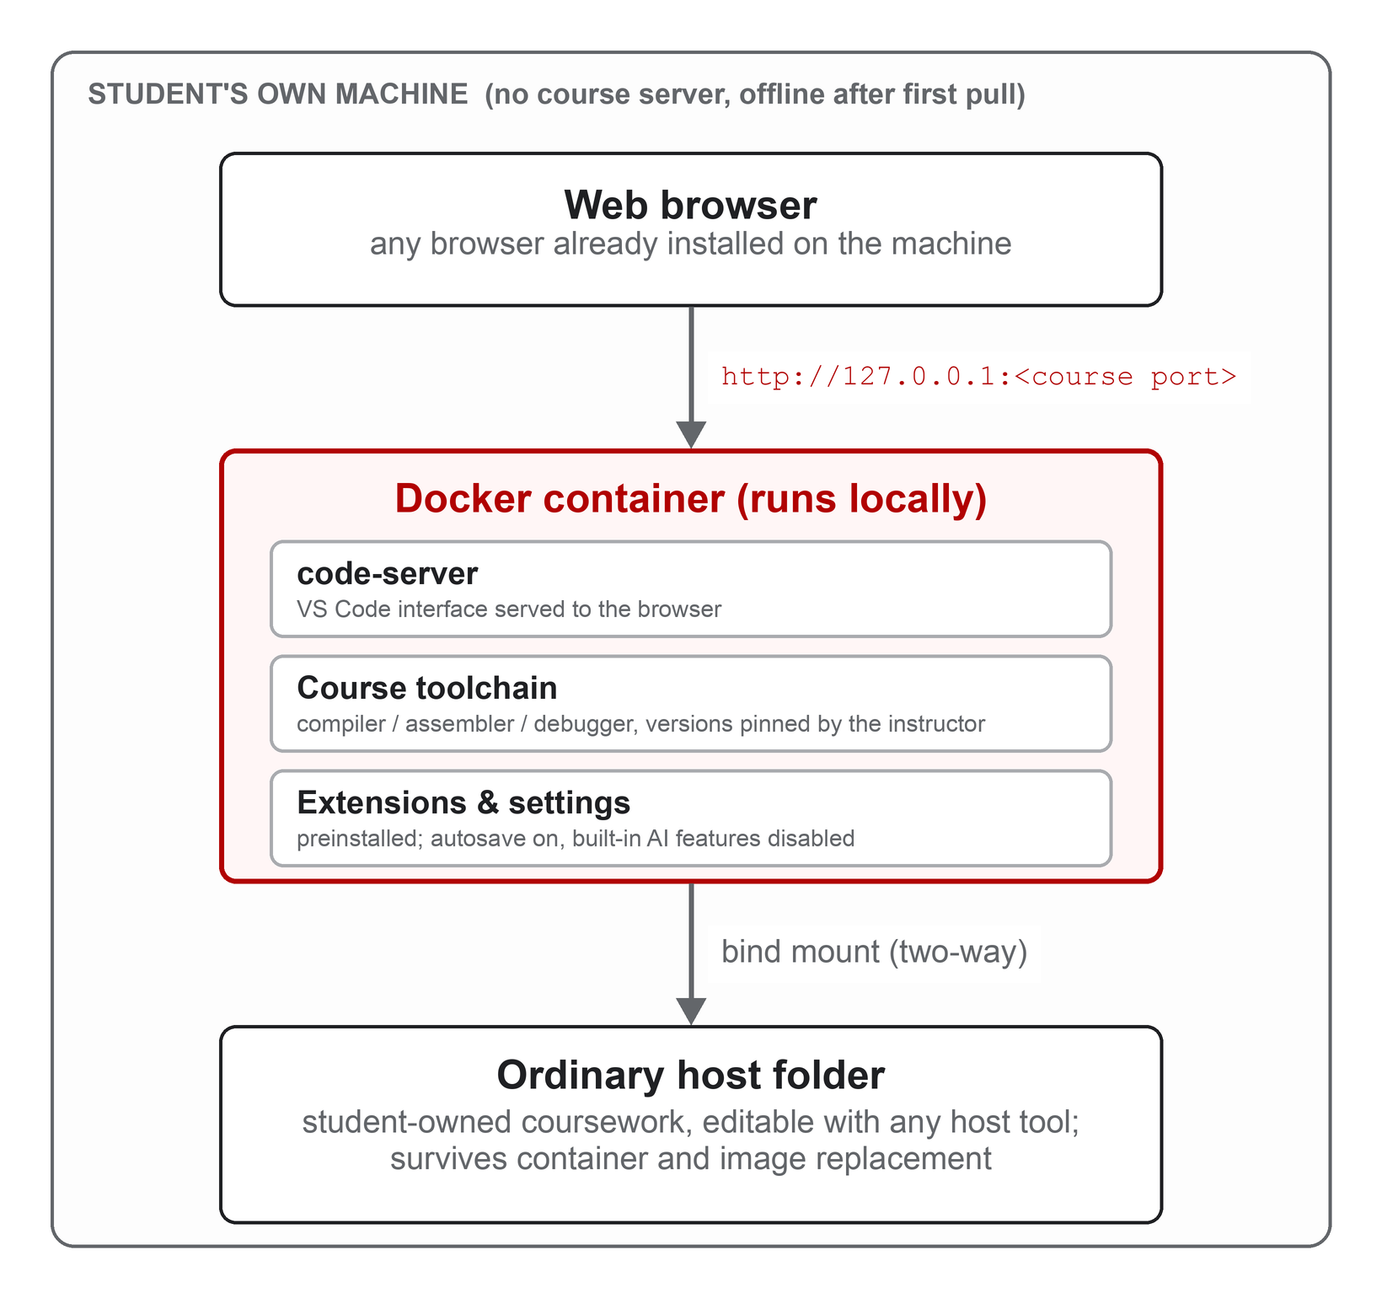
Figure 1. System architecture: the browser connects to code-server over localhost; the container holds the instructor-pinned toolchain; a bind mount keeps all coursework in an ordinary student-owned host folder.
Discuss:
- Base image and pinned code-server version
- Course toolchains and extensions
- Container user and file ownership
- tini and process lifecycle
- Starter-file seeding
- Bind-mount persistence
- Localhost port binding and disabled authentication
- Autosave and update behavior
- AI kill-switch settings
- Multi-architecture publication for C++
- Plain single-platform amd64 publication for x86
- Release checking and documentation-drift checks
Explain design decisions rather than reproducing the Dockerfiles line by line.

10.6 Evaluation method
Separate the evaluation into technical and educational components.

Technical evaluation
Record:
- Image tag and immutable digest; Git commit or release tag
- Docker Desktop/Engine version; host operating system, architecture, CPU, and RAM
- Cold and warm image startup time; image download and on-disk sizes
- Idle CPU and memory; time to compile and execute the starter program
- Native versus emulated x86 execution time; health endpoint result
- Tool and extension versions
- File persistence after stopping, deleting, pulling, and recreating a container
- Starter seeding in an empty workspace and non-overwrite behavior in a nonempty workspace
- Documented command success on each tested platform
- Debugger behavior on native amd64 and emulated ARM hosts
Use repeated measurements where timing is reported. State sample count, whether caches were warm, and report variability rather than a single best run.

Educational evaluation
Before collecting student data, consult the institution's human-subjects/IRB process. Participation should be voluntary where required, and course grades should not depend on survey participation. The planned study flow is shown in Figure 2.
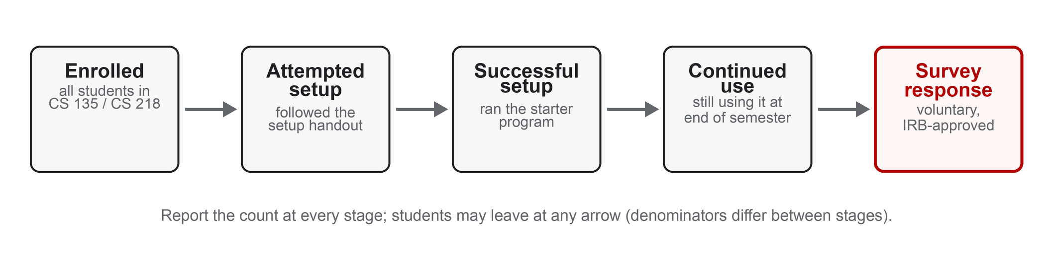
Figure 2. Study flow: report the number of students at each stage so every percentage in the paper has an explicit denominator.
Collect, if approved:
- Prior programming, Linux, terminal, IDE, and Docker experience
- Host OS, architecture, and approximate hardware resources
- Time to first successful starter execution; whether help was needed and how much
- Setup issue category and resolution time
- Environment used during the semester and reasons for switching environments
- Perceived usability and reliability; setup anxiety and programming self-efficacy
- Instructor and teaching-assistant support incidents and time
- Assignment completion or performance, with appropriate privacy and controls
The decentralized design does not require telemetry. Prefer opt-in surveys, setup observation, anonymous issue categories, and staff support logs over silently collecting editor activity.

10.7 Results
Before deployment, report only technical results. Use tables for the platform matrix and resource measurements.
After deployment, report denominators, missing data, response rates, central tendencies, variability, and appropriate statistical tests. Include negative findings and failures. Distinguish: all enrolled students; students who attempted the environment; students who successfully used it; and students who answered a survey.
Do not turn survey agreement into proof of learning. Self-reported usefulness, measured setup time, support burden, and assignment performance are different constructs.

10.8 Discussion
Interpret results in relation to the literature:
- Does the project reproduce the setup and anxiety benefits reported by Fernalld et al.?
- How does setup compare with the DevContainer workflow of Valstar et al.?
- Which CS50 benefits remain without Codespaces?
- What is lost by removing centralized accounts, monitoring, backups, and collaboration?
- Does host-controlled persistence improve student understanding and confidence about file ownership?
- Is the browser interface easier than a desktop editor plus container extension?
- Is emulation sufficient for the assembly curriculum, or should native lab access remain part of the course?
Discuss the warning in the student design documents: abstracting setup is useful in an introductory course, but students eventually need to learn how professional toolchains are configured.

10.9 Threats to validity and limitations
At minimum, address:
- One institution and two courses; small or voluntary survey samples
- Prior Docker and programming experience; self-selection into using the supplied environment
- Instructor and semester differences; changes to assignments or grading between comparisons
- Novelty effects; hardware and network differences
- Docker Desktop installation as a remaining setup dependency
- Image download size and disk use; Linux bind-mount ownership differences
- Disabled authentication being safe only with localhost binding
- Lack of centralized backup or recovery
- ARM emulation overhead and missing ptrace behavior
- Dependence on Docker and code-server as external software projects
- The inability of pre-deployment testing to establish educational outcomes

10.10 Ethics, privacy, and academic policy
Explain that:
- Student files remain on student-controlled host storage.
- The system does not require a course server to store code or activity logs.
- No telemetry should be added merely to make the study easier.
- Any linkage between survey, usage, and grades requires institutional approval and careful de-identification.
- AI features are disabled to implement course policy, while students must still follow the instructors' current policy regarding external tools.

10.11 Conclusion
Answer the research questions using only collected evidence. Summarize the architectural contribution and practical trade-offs. Do not repeat the abstract verbatim.
Before deployment, conclude with what technical feasibility has been demonstrated and state that educational effectiveness remains future work. After deployment, replace that sentence with the measured findings and their limitations.

11. Recommended tables and figures for the paper
Include only figures that clarify an important relationship.
1. Architecture diagram: browser → localhost → container → bind-mounted host folder (Figure 1 above).
2. Design-space comparison: CS50 Codespaces, DevContainers, Lightweight Symphony, CodeDive, and the UNLV system.
3. Platform support matrix: Windows/macOS/Linux × amd64/arm64 × C++/x86 image × debugger support.
4. Environment contents table: toolchains, extensions, ports, architecture, starter files, and image versions.
5. Technical results table: startup, size, memory, compilation time, and persistence checks.
6. Study flow diagram: enrollment → attempted setup → successful setup → continued use → survey response (Figure 2 above).

12. Claims checklist

12.1 Claims currently supported by repository evidence
- The project provides separate C++ and x86-64 assembly images.
- The C++ build targets amd64 and arm64; the x86 build intentionally targets amd64 only.
- Both images expose code-server on container port 8080, and documented host ports allow the images to run side by side.
- Starter files are copied only into an empty workspace.
- The documented workflow uses host bind mounts rather than Docker volumes.
- Autosave is enabled and built-in AI features are disabled.
- Containers do not have automatic restart policies.
- The project includes a release check for documented workflows.

12.2 Claims requiring measured technical evidence
- The images work on every supported host configuration.
- The environment is lightweight on typical student machines.
- Updating never loses student files in all supported host configurations.
- Emulated execution performance is acceptable.
- The interface is easier than alternative setups.

12.3 Claims requiring course data
- Students spend less time on setup; staff receive fewer support requests.
- Students experience less anxiety and focus more on programming.
- Students prefer the browser IDE.
- The environment improves assignment completion, grades, retention, or learning.

13. Writing milestones

Milestone 1 — Annotated reading notes
For each required source, produce 150–250 words covering: research problem; system or intervention; context and participants; evidence and method; main findings; limitations; and how the source supports or challenges the UNLV paper.

Milestone 2 — Literature synthesis
Complete the literature matrix (Section 9) and write a 1,000–1,500-word related-work draft organized by architectural approach.

Milestone 3 — Evidence inventory
For every planned claim, identify one of: repository evidence; technical experiment; student or instructor data; prior literature; or a clearly labeled design goal. Remove or narrow claims with no evidence source.

Milestone 4 — Pre-deployment manuscript
Complete the introduction, related work, requirements, design, technical evaluation, limitations, and study protocol. Mark future educational results explicitly rather than inventing placeholder findings.

Milestone 5 — Course study
After institutional approval, deploy the environment, collect the planned data, document deviations from the protocol, and analyze both successful and unsuccessful adoption.

Milestone 6 — Final revision
Revise the abstract, discussion, limitations, and conclusion based on the actual evidence. Verify every bibliography entry using its DOI or the publisher's citation export.

14. Final submission checklist
☐ The paper does not claim to be the first educational Docker environment.
☐ The paper distinguishes cloud IDEs, local DevContainers, VMs, browser exercise systems, and this architecture.
☐ C++ multi-architecture support and x86 amd64-only support are explained correctly.
☐ Student files are described as host bind-mounted files, not Docker-managed volumes.
☐ Localhost binding and disabled authentication are explained together.
☐ Educational goals are not reported as findings without data.
☐ Survey response rates and denominators are reported.
☐ Historical comparisons are not described as randomized causal evidence.
☐ Negative findings, setup failures, and emulation limitations are included.
☐ Student privacy, institutional review, and data handling are addressed.
☐ Repository tag, image digest, tool versions, and test hardware are reported.
☐ All citations have been checked against DOI or publisher records.

15. Recommended starting order
Begin with these six readings, in order:
1. Malan, “Containerizing CS50” (7.1)
2. Valstar et al., “Using DevContainers to Standardize Student Development Environments” (7.2)
3. Fernalld et al., “Lightweight Symphony” (7.3)
4. Cadenas et al., “Virtualization for Cost-Effective Teaching of Assembly Language Programming” (7.5)
5. Harvie et al., “Using Virtual Machines to Enhance the Educational Experience” (7.6)
6. Ngo et al., “Common Container-Based Infrastructure Blueprints” (7.4)
Then read Malan 2010 and 2013 for the historical argument, Laadan et al. for local appliances, Tan et al. for the VS Code interface, and the Codeboard and CodeDive papers for browser-based alternatives and evaluation methods.

